St. Patrick’s Primary School
Derrygonnelly

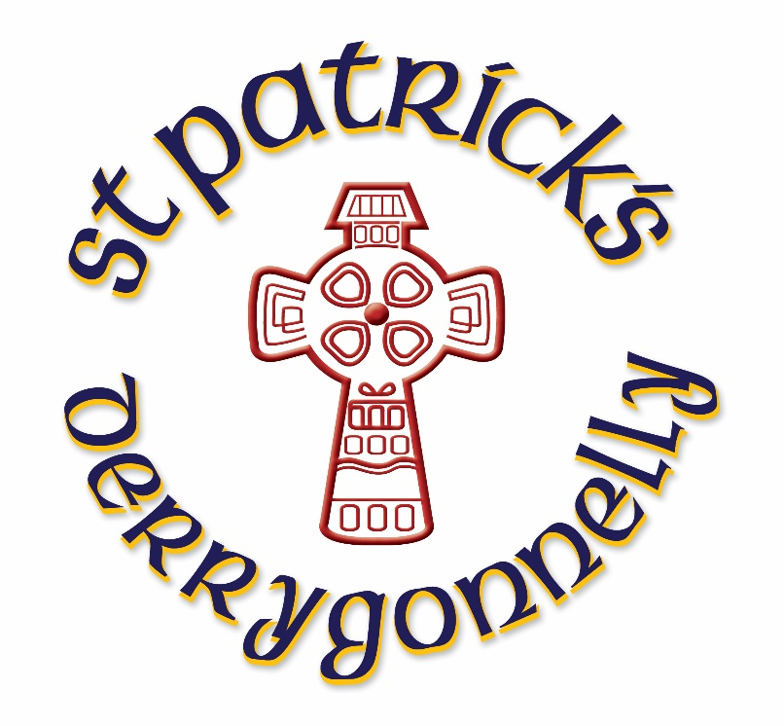

Board of Governors

Annual Report

2020-21

St. Patrick’s Primary School,

Derrygonnelly

Annual Report

September 2020- June 2021

Dear Parent,

It is my pleasant duty, on behalf of the Board of Governors of St. Patrick’s P.S., to present this annual report for the past school year, 2020-2021. The Governors urge you to study the report carefully. It is a record of endeavour and achievement during the year, for which I wish to give credit to our staff, pupils, and parents. Sincere gratitude is also extended to our school chaplain, Fr. Cathal, for the wonderful contribution he has made to St. Patrick’s P.S.

As you read the report you will also find evidence of partnerships between St. Patrick's P.S. and other statutory and voluntary agencies which have enhanced the educational provision for your children. In addition, I want to avail of the opportunity to highlight the significant achievements in the on-going development of St. Patrick’s P.S., as an excellent agency of care for all our pupils.

I wish to record my sincere gratitude to all my colleagues on the Board of Governors. Throughout the past year they have shown great dedication and commitment, in what is an entirely voluntary capacity, on a Board which strives to meet the needs of our pupils.

We look forward to continuing to work together as a devoted team, united by our desire to ensure the very best educational experiences for all pupils entrusted to the care of St. Patrick’s P.S.

This year society continued to face the unprecedented challenge of the Covid-19 global pandemic. As a consequence, all schools in Northern Ireland were closed on 5th January, reopening in a phased manner during March and April. Education was provided through a ‘blended learning’ approach, in particular with the use of online platform Seesaw.

I thank all parents for the manner in which they embraced this new approach in what was such difficult circumstances.

Should you wish to have any additional information or clarification on any aspect of the report, please forward your request in writing to me at St. Patrick’s Primary School.

Yours sincerely,

Mrs Mary Leonard

Chairperson
Board of Governors

OUR AIM

The Board of Governors, Teachers and Staff aim
within a Catholic ethos, to foster a caring Christian
community, which promotes the full and balanced
development of each person in harmony with
God,
oneself, others and the environment.

BOARD OF GOVERNORS

CHAIRPERSON: Mrs Mary Leonard
SECRETARY: Mr P Fitzpatrick

TRUSTEES REPRESENTATIVES
Mrs J Flynn
Mrs M Corrigan
Mrs A Corrigan
Mrs E Harbinson

EA REPRESENTATIVES
Mrs M Leonard
Mr D Cox (replaced by Mr R Dundas in June 2021)

DENI REPRESENTATIVE

Mr G Duffy

PARENT REPRESENTATIVE
Mrs E Love

TEACHER REPRESENTATIVE
Miss A McGarrigle

PRINCIPAL (secretary to board of governors)
Mr P Fitzpatrick

FACTUAL PROFILE
School: St. Patrick’s Primary School
47 Creamery Road, Derrygonnelly,
Co. Fermanagh, BT93 6FZ

Telephone: 028 68641358
email: info@stpatricksps.derrygonnelly.ni.sch.uk
School Type: Catholic Maintained, Co-educational Primary
Enrolment: 114
Admissions Number: 28
Enrolment Number 198
Pupil Attendance: 96.3%

Teaching Staff
Principal: Mr P Fitzpatrick
Year 1 Teacher Miss A McGarrigle
Year 2/3 Teacher Miss C Maguire
Year 4 Teacher Mrs Z McCusker
Year 5/6 Teacher Mrs C McAloon
Year 6/7 Teacher Mrs M Scollan/ Mr Fitzpatrick

Non-Teaching Staff
Secretary Mrs J Connolly
Classroom Assistants Mrs C Muldoon Mrs C Elliott
Miss S McCauley Mrs P Kent
Mrs J Whitehouse Mrs J Scott
Mrs Y Burke Mrs M Duffy
Mrs J McGurn Mrs C Cox
Miss Hovden
Supervisors Mrs A Treacy
Mrs J Connolly
Mrs C Cox
Caretaker Mr G Kent
Cleaner Mrs M Bonner

School Meals Staff
Cook-in Charge Mrs F Johnston
Assistants Mrs C McGurl
Mrs R Parkes

Chaplain: Rev. C Deery P.P.

THE MAIN RESPONSIBILITIES OF THE BOARD OF GOVERNORS ARE:

The Governors are ultimately responsible for the overall management of the school.

Since being established the present Board of Governors has worked closely with the Principal to develop a framework for management of the school which is in keeping with developments in education policy and which best takes account of the particular issues which affect our school.

Responsibilities of the Board of Governors include:

- Catholic Ethos
- School Development planning
- Curriculum and Educational standards
- Pastoral Care
- Employment Practices and Staff Relationships
- Area Planning
- Enrolment and Admissions policies and Practices
- Financial Management
- Annual Report to Parents

The term of office for the current Governors ends in Term 1 2022.

Review of the Year 2020 -2021
Introduction
St. Patrick’s staff focused its concern on the development of children and welcomed the interest and involvement of parents. During the school year 2020 -2021 the staff continued to plan and provide a happy, safe learning environment giving a wide variety of experiences to all pupils.

However, the Covid-19 global pandemic posed significant threat to the consistency and continuation of education. On 4th January 2021, the Education Minister, Mr Peter Weir, announced that all school settings were to close with immediate effect. This remained the case until some primary school classes (P1-3) resumed on 8th March, with the remaining classes resuming on 22nd March. Education during the period of school closure became known as ‘Blended Learning’, a mixture of online learning via the platform SEESAW, and the provision of hard copies of educational resources for pupils. Non-Teaching staff also provided the essential service of ‘supervised learning’ for Key Workers’ children during this period.

The Board of Governors wishes to thank our highly conscientious staff for the many hours of their own time that they have given during the year and for their commitment and dedication to their pupils in what has been a most challenging time.

Catholic Ethos

St. Patrick’s Primary School is an important component of the wider Catholic Community manifesting the same values and beliefs.

Teachers continued to work closely with the parish and parents preparing children for the Sacraments of the Eucharist and Confirmation. Throughout the year the children with their teachers prepared and participated in many ceremonies.

The sacrament of Penance was celebrated in April 2021 by the children of Primary 4, and the children of Primary 7 celebrated the sacrament of Confirmation on Wednesday 28th April and Thursday 29th April, along with Primary 7 children from Killyhommon Primary School. The children of Primary 4 celebrated the sacrament of Holy Communion on Saturday 24th April.

Pastoral Care

The governors and staff of the school continue to place a very high priority on the pastoral care and the general welfare of all pupils and will continue to promote positive and caring relationships between pupils, parents and staff. St. Patrick’s P.S. provides a caring environment within which the academic, personal, social and spiritual potential of each child is developed. The pastoral dimension permeates all school activities.

The governors and staff of St. Patrick’s P.S. have a primary responsibility for the care, welfare and safety of the pupils in our charge, and we will carry out this duty through the full implementation of the Pastoral Care policy, which aims are to provide a caring, safe and supportive environment.

Curriculum

Under the Education Reform Order, the responsibility of governors for the provision of curriculum has been increased. The governors’ control of the curriculum is determined by legislation. However, the day-to-day organisation of the curriculum is a delegated duty of the Principal.
It is the responsibility of the governors to ensure that a broad, balanced curriculum is provided for all pupils. The school continues to develop its curriculum: policies are in place, and are reviewed and updated as required.
In the School Year 2020-2021 staff continued to plan and provide for a learning environment which gave the optimum quality experiences in the academic, social and religious dimensions of this Primary School’s life.
The Education and Training Inspection team (ETI) carried out a full inspection in February 2017 and reported that provision was very good in the areas inspected:

- Outcomes for Learners – Very good
- Provision for Learning – very good
- Leadership and Management – Very good
- Board of Governance – High Level of confidence
- Safeguarding and Child Protection – outstanding

The quality of teaching and learning continues to be of the utmost importance in the development of the school.
The school actively supported the teachers in staff development and training, and hence school improvement. Monitoring and Assessment was ongoing throughout the year both in terms of children’s learning and teachers’ teaching.
Rigorous and robust assessment processes are in place in all classes, culminating in end-of-year assessments.

The Arts
St. Patrick’s were unable to offer after-school activities as mandated by the NI Executive. Many events were cancelled, including the Fermanagh Feis.

Shared Education, Community and Cross-Community Links:

The school Principal continues to be involved in some activities with the Principals of Killyhommon P.S. and Derrygonnelly Controlled P.S.
St. Patrick’s P.S. has been invited to resume involvement in the Shared Education partnership with both local primary schools from 1st September 2021.

Health and Safety:

St. Patrick’s continues to be a health promoting school, investing time and resources in developing healthy lifestyles for all. Health and Safety is of optimum importance.

E- safety has become a priority in our school and the policy is available for all parents. Safety in all its forms is taught within the curriculum and the school participated in some projects such as cycling proficiency, World Internet Safety Day, Road Safety activities, and FODC Farm Safety activities.

The Fire management procedures have been updated and all equipment including exits, extinguishers, alarms etc. are regularly monitored and procedures followed. All Fire Drill log books and registers are kept in the school office.

SPECIAL EDUCATIONAL NEEDS

Children with special educational needs are catered for through careful planning and with extra support in class in accordance with the SENDO legislation.

‘the children, including children with additional needs, make very good year-on-year progress in their literacy and numeracy skills’ ETI 2017

The teachers continued to report to parents on the progress of their children at meetings throughout the year, culminating in a written report during the month of June
The Board of Governors wishes to thank the Educational Psychology Service and the Education Authority (EA) for its help throughout the year. The school staff try hard to provide additional support in spite of financial constraints in the EA.

Fundraising

The school continued to enjoy the very generous support of parents and the wider community.

St. Patrick’s pupils and their families made a significant contribution to the Enniskillen Foodbank this year.

BUILDING, MAINTENANCE AND SECURITY

St. Patrick’s PS complies with all legislation and guidance given by DENI and CCMS.
We thank the parents of our pupils for their co-operation in relation to our efforts to maintain good security in the school. During class time, access to the school is via the front door which has a security device – a visitor sign-in book and ‘Taking children from school book at other times’ book are located at this entrance to further enhance our safeguarding measures.
EA Contractual Cleaning Services continue to provide cleaning and grounds maintenance services. The caretaking staff are to be commended for the presentation of the school and we appreciate their hard work and dedication.
The Board of Governors is grateful for the advice and assistance given by the C.C.M.S and Education Authority officers.

Parent Teacher Meetings

As recommended by the DENI and EA the school was unable to host parent-teacher meetings. Teachers made arrangements to discuss pupil progress and achievement with parents via telecommunication.

The governors appreciate the hard work of the teaching staff to facilitate these function.

APPRECIATION

The Board of Governors wishes to thank the Principal and teachers for their commitment, dedication and professional care which they show all pupils. They appreciate the significant contribution made by all support staff, including, office secretary, classroom assistants, supervisors, caretaker, cleaner and school meals staff, to the daily life of the school and thank them for their dedication.
The Board of Governors thank all parents for their contribution to the life of the school throughout the year. The partnership we experience with parents is never taken for granted, and we look forward to your continued support.
We wish to express thanks to all external agencies, including the bus operators, who continue to provide a careful and valuable service.
The Board of Governors extends sympathy to staff members and pupils who have suffered bereavements in the 2020-2021 school year.

Calendar of Events/Activities
Term 1

PATHS continues in all classes, Years 1-7.
Swimming lessons are not being accessed during Term 1 due to lack of reassurance that safety measures are sufficient and also parental concerns/reasoning (implication for some families if others within a ‘protective bubble’ attend. Gaelic Coaching for P4-7 classes continues, with coach Fergal.
Physical Literacy coaching continued with coach Eimear Keenan providing lessons to all classes during Term 1 and 3.
Miss Sinead Feeley provided SpLD support for one pupil.
Mrs Olivia Edwards provided SEBD support for two pupils.
RISE provided Speech and Language support to two pupils during Term 2/3.
RISE Physiotherapist provided support to one pupil during Term 3.
Peripatetic Support in Violin continued, with Brenda McAleer as tutor, for Terms 1 and 3.

Liturgical Events:
The sacrament of Confirmation was celebrated by former Primary 7 pupils (Year 2020) on Tuesday 8th and Thursday 10th September.
The sacrament of Holy Communion was celebrated by Primary 5 pupils on Saturday 12th September.
Fr Cathal celebrated a special mass for Grandparents on Wednesday 27th January, as part of Catholic Schools’ Week.
Bishop Duffy celebrated the ‘Service of Light’ from Monaghan Cathedral on Wednesday 21st April for all children preparing for Confirmation.
The sacrament of Confirmation was celebrated by Primary 7 pupils on Wednesday 28th and Thursday 29th April.
The sacrament of Holy Communion was celebrated by Primary 4 pupils on Saturday 24th April.

Other Events/Activities
The school celebrated Roald Dahl Day on Friday 11th September 2020.
P7 Reunion event took place on Monday 5th October 2020 – with presentations and video messages from special guests.
Halloween Fancy Dress activities took place on 16-10-2020.
FLU Vaccination programme was delivered on Wednesday 11th November 2020.
School Photographer visited on Wednesday 25th November 2020.
Parent-teacher meetings took place via telephone calls (as stipulated by PHA and EA regulations) during December Term 1 and January Term 2.
Pupils/parents of St. Patrick’s P.S. donated very generously to the Foodbank Appeal.
W5 Science team delivered a ‘One hour of Coding’ workshop for Primary 6/7 on Thursday 10th December 2020.
Mental Health Week activities took place during w/c 1st February 2021.
Internet Safety Day on Tuesday 9th February 2021.
World Book Day events w/c 1st March 2021 facilitated by Miss McGarrigle (David Walliams Interview, Kahoots Quiz and Potato Characters)
St. Patrick’s Day assembly via ZOOM on 16th March 2021.
Live ZOOM GAA lessons and Covid-Cruncher programme by Miss Keenan during February and March 2021.
YENI Business Beginnings programme for P7 – pupils created their own company ‘Rainbow Magic’ Ltd. They processed and fulfilled orders, and thoroughly enjoyed the programme.

Sustrans activities:
Ditch the Dark Day took place on 13-11-2020.

Engage Programme:
Mr Fitzpatrick delivered the Engage programme to a range of pupils from Primary 2-7 for four weeks in November 2020. This programme aimed to reduce the impact of Lockdown on both educational attainment and Health and Well-being. (Primary 2 group, P4 individual pupil, P5 class and P7 class).
Mr Fitzpatrick delivered a similar programme to a range of groups of pupils, including the P7 class for the YENI Business Beginnings Programme.

Remote Learning Period
St. Patrick’s P.S remained closed to pupils from Tuesday 5th January – Monday 8th March (Primary 1-3)/Monday 22nd March (Primary 4-7)
Teachers used a combination of both online (via SEESAW) and Learning Pack activities to ensure continuation of learning.
Non-Teaching staff provided Key Workers’ children supervision during this period.

