St. Patrick’s Primary School

Numeracy Policy
St. Patrick’s Primary School

Literacy Policy

St. Patrick’s Primary School

Literacy Policy

St. Patrick’s Primary School

Literacy Policy

PRINCIPLES:

We view the development of Numeracy as an entitlement for all pupils and therefore the responsibility of all teachers - the whole school - in partnership with the pupils, parents, Board of Governors, Education Authority and other support agencies.

In St. Patrick’s P.S., the following definition of Numeracy as laid out in, 'Count, Read: Succeed: guides the teaching and learning in this area of the curriculum: 1

'Numeracy is the ability to apply appropriate mathematical skills and knowledge in familiar and unfamiliar contexts and in a range of settings throughout life, including the workplace. It involves the development of:

- An understanding of key mathematical concepts and their inter- connectedness;

- Appropriate reasoning and problem-solving skills;

- The proficient and appropriate use of methods and procedures (formal and informal, mental and written); and

- Active participation in the exploration of mathematical ideas and models'.

We aim to promote the enjoyment of Numeracy as an essential life skill in line with this definition and in conjunction with the overall aim of the NI Curriculum, '...to empower young people to develop their potential and to make informed and responsible choices and decisions throughout their lives.'2 In order to do so, we will provide pupils with the necessary language, concepts, skills and confidence to, '... help young people develop as: individuals, contributors to society ... the Economy and Environment' 3 As such, we see the acquisition of Numeracy skills as something central and relevant to the everyday lives of our pupils, not as an abstract body of knowledge to be drawn upon in later life.

1 'Count, Read: Succeed -A Strategy to Improve Outcomes in Literacy and Numeracy' Section 1:10. (DE) 2010.
2 'The NI Curriculum- Primary'. (CCEA) 2007.
- Page 4, 'The NI Curriculum- Primary'. (CCEA) 2007.

In St. Patrick’s P.S., we believe that, '...a high priority [should be given] to the development of numeracy across the curriculum'. 4 It is therefore important that the numeracy skills of pupils are developed in the context of other learning areas with a particular emphasis on 'Using Maths'5.

Effective numeracy development should also promote a positive attitude to mathematical learning and to the development of pupils' 'Thinking Skills and Personal Capabilities.'6

In an increasingly digital world, we believe that our pupils should make full use of Information and Communications Technology (ICT) to enhance, extend and transform their learning in Numeracy. Where appropriate, staff should also make full use of ICT in their teaching, planning, assessment and continuing professional development.

PURPOSES

At St Patrick’s the purposes of the teaching and learning of mathematics/ numeracy are:

  - To raise mathematics/numeracy standards by enhancing the quality of learning and teaching;
  - To enable children to become increasingly confident in their application of their mathematical skills;
  - To promote leadership and management of mathematics/numeracy at all levels in the school;
  - To incorporate the appropriate use of ICT in the teaching of mathematics/ numeracy;

  - To provide staff development which will ensure a shared understanding, common approach and consistency across the school.

- 'Better Numeracy in Primary Schools- Evaluations and prompts for self-evaluation'. (ETI) 2009
5 'The NI Curriculum- Primary'. (CCEA) 2007
6 'The NI Curriculum- Primary'. (CCEA) 2007

We aim to promote in pupils:

- An awareness of the role mathematics can play in the world beyond the classroom - providing opportunities for problem-solving and using creative abilities;
- An ability to apply the mathematical vocabulary and concepts taught in school, to the world in which they live;
- An awareness of the power of mathematics/numeracy to communicate, analyse and explain information and ideas;
- An ability to use mathematical skills as a powerful tool for other work and areas of study;

- An ability to think clearly and logically in mathematics/numeracy with confidence, independence of thought and flexibility of mind;
- A feel for number and an understanding of mathematics/numeracy through the process of enquiry and experiment;
- An appreciation of mathematical pattern and the ability to identify relationships;

- Mathematical skills and knowledge accompanied by the quick recall of basic facts

- The development and use of mathematical language;

- Persistence, reliability and accuracy through sustained work in mathematics/numeracy which requires some perseverance over a period of time.

The following aspects of 'Every School a Good School, are reflected in our provision for Mathematics and Numeracy:

Child-Centred Provision:

- Teachers plan in accordance with the needs and aspirations of the pupils in their class. Staff plan with the children, taking into account their prior learning, and this is made visible through a variety of approaches in all classrooms using, for example, KWL/planning boards and 'Learning Walls;

- A culture of high achievement exists in all classrooms. Staff have high expectations that pupils can and will achieve to the very best of their ability;

- Learning outcomes are differentiated in planners, recognising the range of abilities that exist in all classrooms, including those pupils with Special Educational Needs and children who are gifted and talented;

- Numeracy resources and lessons reflect the variety of learning styles that pupils have;

- Dyslexia friendly teaching approaches and methodologies are employed in the teaching of Numeracy;

- Staff value pupil contributions to Numeracy lessons and promote a culture of risk taking when tackling problem solving;

- The needs of Newcomer pupils are recognised and diversity cherished;

- Effective intervention strategies are in place to ensure that pupils who need additional support receive it;

- Pupils are given an opportunity to reflect on their own work in Numeracy and that of their peers through self and peer assessment.

High Quality Teaching and Learning:

- 'Learning in Mathematics is incremental.'7 Teachers ensure that they begin a new Numeracy topic by clearly establishing what the children already know, understand and can do;

- Teachers relate their Numeracy lessons to everyday life and provide pupils with a context for their learning;

- Staff seek to enthuse pupils' interest in Numeracy as something that extends beyond the classroom as a valuable means of understanding the world around them;

- Teachers have a firm knowledge and understanding of mathematical vocabulary and are acutely aware of the implications of introducing this language to children;

- Page 14, 'Better Numeracy in Primary Schools- Evaluations and prompts for self-evaluation'. ETI. 2010.

  - Numeracy /Mathematics is used to develop and deepen pupils' knowledge and understanding of other curricular areas;

  - Staff use practical approaches to develop mathematical concepts and to lay the foundation for more abstract work8
;

- Working in conjunction with their teacher, pupils are encouraged to set, and work towards, the achievement of their own targets. Teachers use formative assessment strategies to encourage pupils to reflect on their own work and improve upon it E.g. Marking is diagnostic and supportive and involves a conversation with the child, incorporating such strategies as 'Two Stars and a Wish';

  - A variety of teaching and learning approaches are clearly evident in meeting the needs of a variety of pupil learning styles, in Numeracy lessons;

  - Teaching styles are adapted to meet the needs of pupils who are identified as: achieving, low achieving, underachieving and gifted and talented;

  - Teachers use effective questioning to probe pupils' understanding and to develop reflective and critical thinking;

  - Numeracy lessons are discursive, well-paced, ambitious and interactive. There is an emphasis on good quality dialogue between teacher and pupil;

  - Thinking Skills and Personal Capabilities are an integral part of Numeracy lessons. Regular opportunities are provided for pupils to problem solve and carry out investigations.

  - Problem solving and investigative activities are seen as an opportunity to draw out the strategies used by the pupils when carrying out their work;

  - Teachers model how to problem solve using a variety of strategies and pupils know and understand these;

- Page 6, 'Better Numeracy in Primary Schools- Evaluations and prompts for self-evaluation'. (ETI) 2010.

- A culture of risk taking is promoted by the teacher in which pupils are encouraged to 'have a go', without the fear of failure;

- Numeracy lessons have clear learning intentions and success criteria -including when carrying out practical work;

- Pupils' mental strategies are encouraged and promoted. This will include 'mental starters/warm ups, and incidental opportunities which arise during Numeracy lessons;

- Children are provided with opportunities to work individually, with partners or in groups;

- The use of Information and Communications Technology is carefully planned to support the learning outcomes in Numeracy, motivate pupils, consolidate their learning and extend their problem-solving capabilities. The 5 Es are clearly evident in in Numeracy lessons. Interactive Whiteboards are used by teacher and pupil, during lessons, to deepen understanding and knowledge in Numeracy;

- The plenary, at the end of the lesson, is used effectively to draw upon the learning intentions and to formatively assess children's learning;

- There is a systematic approach to the development of pupils' Mathematical knowledge and understanding of Numeracy, throughout the school. For example, to the development of pupils' understanding of place value. Teachers are skilled in building upon the children's learning at every stage in their development. A whole-school Numeracy overview is used to ensure progression and continuity and to avoid overlap;

- Staff reflect upon and self-evaluate their teaching, seeking at all times to improve and build upon their current practise in Mathematics through Continuing Professional Development;

- Teachers effectively use assessment and other data to meet the learning needs of individual pupils, their class and the whole school.

Effective Leadership:

  - The School Development Plan establishes clear and realistic targets for Numeracy;

  - The Numeracy Co-ordinator promotes the effective development of Numeracy throughout the school and serves as a role model for good practice. As Co­ordinator she provides CPD for staff, collates and analyses data and provides advice on a day­ to-day basis;

  - Numeracy priorities for each school year are effectively met through the Numeracy action plan;

  - The Numeracy Co-ordinator in conjunction with the SMT ensures that all data is rigorously analysed as part of the target setting process. This includes qualitative data (from teachers' observations etc.) and quantitative data (from standardised tests). The school uses GL Assessment's Progress in Maths test (PIM) to quantitatively measure the children's achievements in Mathematics. PIM is used to identify those pupils who are achieving in line with their ability, are achieving beyond expectations, are under achieving or are low achieving.

  - Data is used by the Numeracy Co-ordinator, SMT, and SENCO to ensure that the needs of pupils effectively met. Target groups are established in relation to under achievement. Pupils with Special Educational Needs will have their targets met through Individual Education Plans (IEPs). Teachers will liaise with the SENCO and Numeracy Co-ordinator in the event of having a concern with regard to a pupil's progress in Numeracy. The school
will follow the recommended process in 'Count, Read, Succeed'9 regarding intervention;

  - The SMT monitor Numeracy achievement in relation to outcomes for pupils on FSM and gender;

  - Targets in relation to maximising pupil outcomes, form an essential aspect of the Numeracy action plan;

- Page 41, 'Count, Read: Succeed -A Strategy to Improve Outcomes jn Ljteracy and Numeracy', DE. 2000. (See Appenrux 1).

  - Pupils progress is tracked in relation to individual, class and whole school achievement;

  - Continuing Professional Development Needs of staff are met by the Numeracy Co­ ordinator;

  - The purchase of Numeracy resources are costed in the Numeracy action plan and are subject to financial management procedures through the school's LMS budget;

  - The Numeracy Co-ordinator ensures effective transition from Nursery to the Foundation Stage and from Primary to Post-Primary. They ensure that observations and baseline assessments are used effectively in Year 1. The Numeracy Co-ordinator ensures that all data is passed on to the post-primary schools to which children are transferring. They also ensure that Numeracy data is passed on to the relevant statutory agencies when required.

  - The Principal, Numeracy Co-ordinator, SMT and Governors, monitor and evaluate the success of the Numeracy Action Plan on a yearly basis;

  - The Numeracy coordinator will monitor teachers' planners on a monthly basis to ensure:

    - Continuity and progression;

    - Learning outcomes are clearly defined;

    - Relevant mathematical vocabulary is identified;

    - There is appropriate differentiation;

    - Assessment opportunities are identified;

    - Cross-curricular work is evident.

- The Numeracy Co-ordinator will carry out observations and Book Scoops. Samples of work will also be collected as part of monitoring and evaluation process.

A School Connected to its Community:

  - Numeracy is promoted throughout the school, with bright and vibrant Numeracy displays highlighting what is currently happening in each class;

  - Maths Week Ireland and the World Education Games (Mathletics) raises the profile of Numeracy within and beyond the school. It underlines the importance of Numeracy as a life skill;

  - Competitions such as the Sentinus STEM Construction Challenge, provide numerous opportunities for pupils to engage with children from other primary schools and to use their maths;

  - Pupil visits to Tesco, for example, reinforce concepts such as Fair Trade and budgeting;

  - Pupils are aware that being numerate is something of global importance through 'Mathletics', when they get an opportunity to 'compete' with students around the world;

  - Teachers communicate with parents on how their children are progressing in Numeracy, though the use a homework diary;

  - Numeracy homework is set on a regular basis to support work completed in class, to reinforce new learning outcomes and to consolidate prior learning. Homework will include written tasks, practical investigations, games and mental mathematics activities;
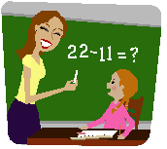

  - Parents are invited to school to discuss their child's progress in Numeracy, through an annual parent/teacher meeting;

  - In the event that a teacher has a concern about a pupil's progress in Numeracy, an additional parent/teacher meeting will be arranged to discuss this;

  - Parents are invited to participate in Numeracy through Parental Involvement in Numeracy programmes.

    - Shared Education is used effectively to promote Numeracy in the wider community and shared classes focus on improving Numeracy outcomes.

    - Joint professional development for Numeracy, through Shared Education, contributes to the sharing of good practice;

- St. Patrick’s P.S. works closely with a variety of external agencies. The Numeracy Co- coordinator attends training provided by the Education Authority’s Numeracy team. The Principal, Numeracy Co-coordinator and SENCO liaise closely with the Educational Psychology, SEN and SpLD services, with regard to pupils experiencing difficulty in Numeracy.

- The school looks forward to developing transition links with Post-Primary schools

through the proposed KS2/KS3 CPD project proposed by the Education Authority.

Policy Revised: September 2016 Next Revision :June 2018

Numeracy Co-ordinator: _______________________________

Date:_ _
Chair of Governors: _________________________
Date:_ _

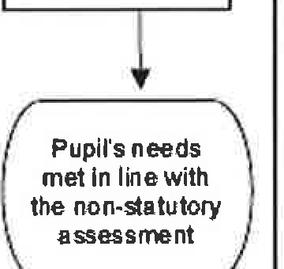

Appendix 1

Page 41, 'Count, Read: Succeed- A Strategy to Improve Outcomes in Literacy and Numeracy', DE. 2000.
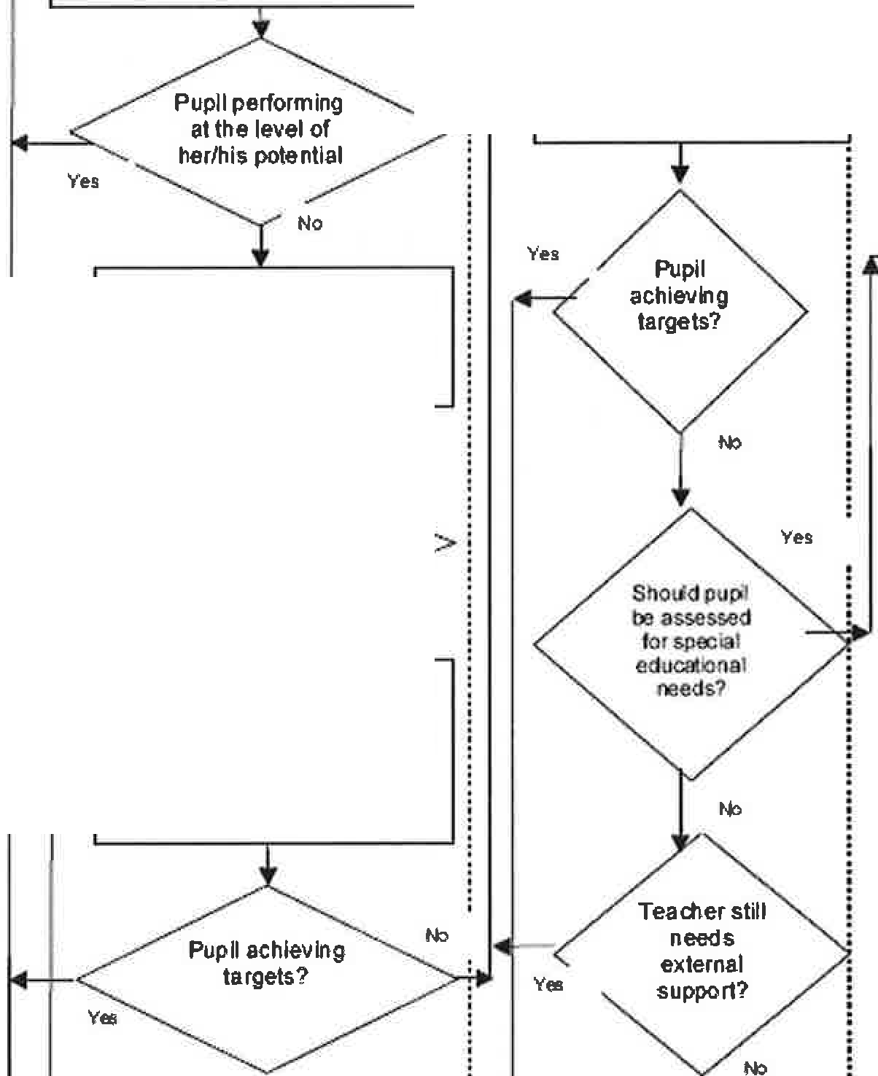

W h In school Vlflthl  externa Isu | n school w•h After a non-statutory  . rt for the teacher assessmen t
High-quality teaching, based on
high eJCpectations for all pupils, Pupil gets 1or more cyde
with good differentiation and oftime-bound additional
tracl<ing and monitoring support, with external
bv the classtsubiect teacher advice for teacher, e.g. from the ELBIESA/ other
schools/ health workers by the classtsubject teacher with external help

Non-statutory assessment
Emerging Underachievement: undertaken
Pupil gets 1 or more cycle of
time ound additional support by the class/subject teacher

chleving
v -----.t..a.rgets?
No

Continuing Underachievement: Pupllgets1 or more cycle of time ound additional support by the classtsubject teacher with input from other school staff

Pupil stiU needs
+- additional in-
school support?
Yes

No

